CLASS : X (2022-23)

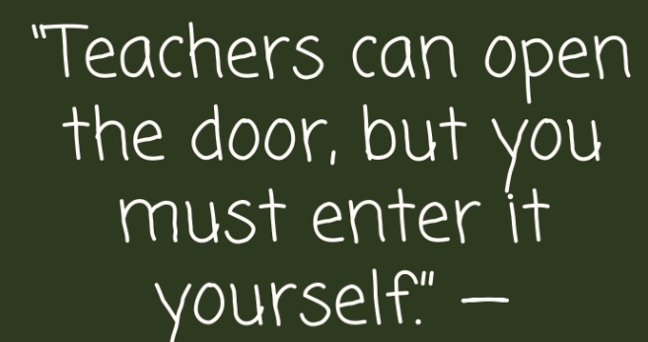

ENGLISH:

EK BHARAT SHRESHTHA BHARAT:
- Make a project on Sikkim highlighting its location and culture covering all aspects of
language, music folktale, dance forms literature and location.
b. Read lesson ‘Bholi’ and create a magazine mentioning five important women of India who
were able to reach zenith.
c. Draw sketch of Nelson Mandela and Tea Gardens of Assam.
d. Read and paste articles of Karan Thapar and Mark Tully appearing on Sunday 'The Hindustan
Times’ and paste in your folder with heading 'Words of Wisdom’.
e. Revise all completed portions of English.

Note: The English work to be done on A4 white ruled sheets and fix it in a folder.

SCIENCE:
BIOLOGY :
- Do practical work.( Will be uploaded in Skolaro)
- Draw, color and label any two human organ systems on A3 size sheet.
- Do given assignments in class notebook.
PHYSICS :
- Practice all the ray diagrams of spherical mirrors and spherical lenses.
- Revise all the topics of reflection and refraction.
- Do given assignments in class note book
CHEMISTRY :
1. Revise the topics done in the class.
2. Say no to plastic on world ocean day 8th June 2022. Impact of single use
plastic.
3. Government of Sikkim celebrates National Science Day ‘TARA’ and other institutions are
invited for the Science Exhibitions. List the exhibition along with pictures done by them.

HINDI:
1. सिक्किम में अपनाए जाने वाले धर्मों व नृत्यों की चित्र सहित जानकारी की परियोजना बनाएँ।
2. किसी प्रसिद्ध कवि की जीवनी और उनकी एक कविता A-3 शीट पर लिखिए।
3. शरीर के भिन्न -भिन्न अंगों पर आधारित कोई 20 मुहावरे एकत्रित कीजिए और उनके अर्थ लिखकर वाक्य में
प्रयोग कीजिए।
4. अनुच्छेद लिखिए - उत्तम स्वास्थ्य वरदान , गुरु शिष्य संबंध
5. पढ़ाए गए पाठों को याद कीजिए।

MATHS:
1. Sikkim is home to many monasteries with stunning architecture and colour interiors. Collect information about architecture, decoration on the walls and silent features of these buildings with reference to Plane and Solid geometry. (Any 5 monasteries)
(Text should be supplemented with lots of images and graphics.)
2. Complete your lab active file, Activities will be shared on Skolaro.
3. Revise the syllabus done till date.
4. Do Assignment Based on Polynomial , Real number and linear equation in two variable sent as an attachment on Skolaro.

ART/CRAFT:
1. Warli painting in A2 size sheet.
2. Complete the work done in class.

SOCIAL SCIENCE:

ECONOMICS:
1. On A3 Size Sheet make a detailed information and description about Sikkim.
a. Infant Mortality Rate
b. Net Attendance Ratio
c. Size of population
d. Income
e. Literacy Rate
GEOGRAPHY:
2. Make a working model on:
a. Different landforms
b. Any ancient civilization.
HISTORY:
3. Make a project on historical background of Sikkim.
- Their rulers
- Religion
- Deities they worshipped
- What was going on in Sikkim when India got independent

